
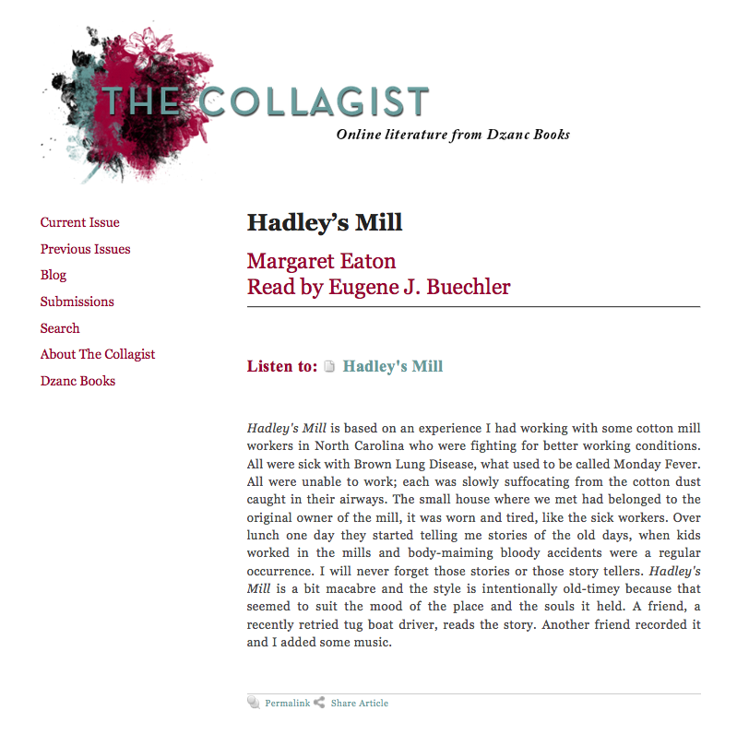
Or read the story on next page.

Some people swore that the house was haunted. But it wasn't the house, it was the mill. That's why Doc had to do what he did. A lot of people did die in that house. Even more bled in there, as much as you can bleed without dyin’. Doc Mason would get there as fast he could, to sew up the ones that had a fightin’ chance. He'd put the others back together best he could before their people showed up to pay their respects. Doc thought he was helpin’ the workers but mostly he was helpin’ Mr. Hadley. Hadley owned the mill. He paid Doc real good to make those accidents look like they weren't so bad. But everybody knew. Everybody in town worked at the mill. That's all there was. Hadley's office was in that house, it wasn't more than a hundred feet from the mill.

When somebody got caught in a machine, Hadley's men would run the body over to the house, spillin’ blood everywhere. Most were real gushers. Hadley, he'd put on a raincoat and call Doc Mason. If it looked real bad, he'd call Preacher Dan too. Now Francine she was a piece of work, she worked for Hadley, she always said there wasn't enough cotton in the whole county to sop up all the blood that come out of those poor souls. She’d clean. Then clean some more. She’d have to wash the floors down with bleach water. Mostly it was the power looms, they'd take your whole arm right up to your throat. Heddles and harnesses get goin’ so fast, you had to focus. Saw a woman get scalped once. Her hair got caught in a giant spinner.

It's a whole ‘nother thing to see a kid get mangled up. Hadley used kids to oil the tops of the spindles, up high, above the weavin’ machines. Hundreds of spindles. All needed oilin’ all day to keep the thread running smooth. Those kids were like acrobats, barefoot too. In and out, up and down, so quick Hadley almost never had to stop the engines to get the spindles oiled. When a child fell, and landed on them machines, Lord, it was not pretty. Those movin' parts, they were so big, so heavy, moving so fast. You had a real mess. Your whole section got shut down and you had to help clear the debris. That's what they called it. Debris. Sometimes they'd turn the power back on so fast a wet clump a blood would get pulled into the thread, making pink squiggly lines in the run. Some fleshy bits got twisted in there too. End up on a spool, then in somebody's towel that they bought at the JC Penny.

Hadley was a cold bastard. Died from a blockage. Couldn't eliminate. He didn't tell no one till it was too late. He didn't have no kin, no friends, so he left the mill to Doc. Thing was, Doc hated that mill. The day Doc found out, he made his last house call. Ate dinner, then drove over to see May Carter, she was sick with the brown lung. Had the yellow eyes and gray skin they all get. And an oxygen tank. Forty-seven and couldn't breathe. Her son moved in to take care of her. He had half a hand and a poked-in eye. When Doc left May he drove straight to the mill. Went inside with a bottle of bourbon and a pack of cigarettes and lit hisself on fire. Took the whole thing down with him. The whole goddamn thing.

Hadley’s Mill

Published as an Audio Story on The Collagist

